|  |
| --- |
|  |
| Capstone Project Document |

**Carrier Trading Center**

Report #1 – Project Introduction

|  |  |  |
| --- | --- | --- |
| **Carrier Trading Center** | | |
| **Group Members** | Lê Văn Dương | SE03290 |
| Vũ Văn Quyết | SE03344 |
| Đặng Lê Tuấn | SE03807 |
| Trịnh Đình Quyết | SE03159 |
| Lê Gia Hoàng | SE03200 |
| **Supervisor** | Mr. Nguyễn Văn Sang | |
| **Project code** | CTC | |

**- Hanoi, 01/2017-**

# SIGNATURE PAGE

AUTHOR: Trịnh Đình Quyết 10/01/2017

Team member

REVIEWERS: Lê Văn Dương 11/01/2017

Project manager

APPROVAL: Nguyễn Văn Sang --/--/2017

Supervisor

**Record of change**

*A - Added M - Modified D – Deleted

|  |  |  |  |  |  |
| --- | --- | --- | --- | --- | --- |
| Effective Date | Changed Item | A,M,D | Change Description | Reason for Change | Rev. Number |
| 10/01/2017 | Create Introduction | A | Create Introduction | First version | 1.0 |
|  |  |  |  |  |  |
|  |  |  |  |  |  |
|  |  |  |  |  |  |
|  |  |  |  |  |  |
|  |  |  |  |  |  |
|  |  |  |  |  |  |
|  |  |  |  |  |  |
|  |  |  |  |  |  |
|  |  |  |  |  |  |
|  |  |  |  |  |  |
|  |  |  |  |  |  |
|  |  |  |  |  |  |
|  |  |  |  |  |  |
|  |  |  |  |  |  |
|  |  |  |  |  |  |
|  |  |  |  |  |  |
|  |  |  |  |  |  |
|  |  |  |  |  |  |
|  |  |  |  |  |  |
|  |  |  |  |  |  |
|  |  |  |  |  |  |
|  |  |  |  |  |  |
|  |  |  |  |  |  |

Table Contents

SIGNATURE PAGE 1

1 INTRODUCTION 4

1.1 Purpose 4

1.2 Acronyms and Definitions 4

2 ABSTRACT 4

3 LITERATURE REVIEW 4

4 PROPOSAL 5

4.1 The idea 5

4.2 Objectives 5

4.3 Brief description about system 6

4.4 System features 6

4.4.1 Client features 6

4.4.2 Admin features 7

5 BENEFIT FROM PROJECT 8

5.1 For our group 8

5.2 For Community 8

6 CRITICAL ASSUMPTION AND CONSTRAINTS 8

7 POTENTIAL RISKS 9

8 REFERENCES 9

# INTRODUCTION

## Purpose

This document is created as the introduction for project Carrier Trading Center – our Capstone Project at FPT University. In this document, we will descript the overview of some existing systems, the initial idea for our project, a brief description about our expected system and some potential risks, critical assumptions, constrains. Moreover, this document also shows opportunities what it offers for users.

## Acronyms and Definitions

|  |  |
| --- | --- |
| **Acronym & Abbreviation** | **Definition** |
| CTC | Carrier Trading Center |
| FPTU | FPT University |
| Q&A | Question and Answer |
| GoodsOwner |  |

**Table 1-1:** Definitions and Acronyms

# ABSTRACT

In fact, there is a high rate of empty trucks on return; it leads to low economic efficiency. Therefore, we create this software to resolve the problem. Our software which supports driver participates in an auction to transport cargo. Someone who interested in carriage will be served with the cheapest price as possible and drivers will not return on the empty trucks. Our software is a transport trading floor on internet. The owner of goods can post their cargo, ceiling price,.…on the trading floor and the drivers or transportation company can joint in the bidding. This is beneficial for both sides. We hope our software not only improve the economic efficiency but also the social life.

# LITERATURE REVIEW

There are some applications or websites have worked about this subject. You can post an article to looking for transport service or searching someone who have demand on carriage. For example: <http://sanvanchuyen.vn/>

“Sanvanchuyen.vn” is a social networking website which connects the owner of goods and shipper.

* Advantages:
* Quickly post
* Finding partner easily
* Free
* Price pinning
* Auction
* Disadvantages:
* There is no reliable verified information
* It is difficult to auction
* **Sanvanchuyen.vn**

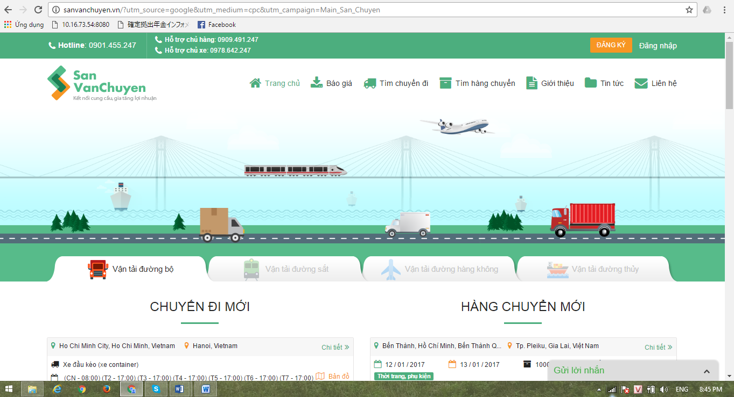Figure 1: Website sanvanchuyen

# PROPOSAL

## The idea

Today there are many who need freight but are not know how to transport as well as being subject to a relatively high fee for it. that is parallel to the transport vehicle after the first leg, the second leg of their ratios were very high without this makes productivity and profitability becomes lower. Our projects - Carrier Trading Center born to addressing these issues. Help people get higher economic profit.

## Objectives

This project is the Capstone Project in FPT University studying program.

First, this project is responsibility for all team members. We must complete all requirements from teacher and FU. During the time doing project, we can learn how to develop a project, how to manage project, how to communicate better between team member, how to control time, how to perform teamwork effectively. Moreover, we also have experience in Java technology, website designing, software testing Therefore, we think this project is very necessary for us to improve skills, knowledge which we studied in FU. This project also makes our CV more beautiful after graduating from FU. This is also an opportunity for us to prove capacity with recruiters.

We want to help people around me, they want to improve the conditions of life as well as Vietnam makes no traffic overload. Especially our website displayed entirely in Vietnamese. Vietnamese can use this website easier

## Brief description about system

This software is a major platform for crowdfunding with friendly and attractive interface, users can easily find out interesting project to back or create a new project with their idea. User also can send opinion to admin if they need help.

CTC uses familiar technologies as: JFS, spring framework, Hibernate… And we are planning to develop a mobile version for easily connecting.

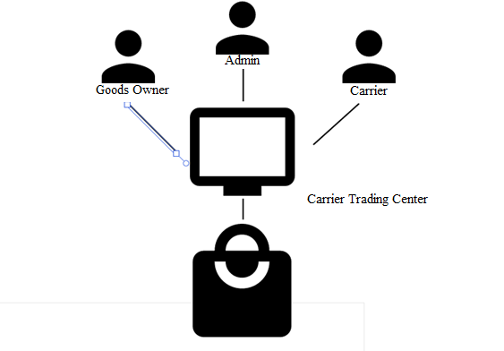

Figure 2: Figure 2: Brief descriptions diagram of CTC system

## System features

About the features of CTC, we focus to provide for user main features as searching, filter project, create new project, back project, etc. Admin can manage members, manage projects, manage database, manage contribute database and manage Q&A.

In here, we focus on features which can help users can understand the best way what user want to have with features of CTC. There are the detailed features of CTC:

### Client features

#### Goods owner features

* **Manage auction:**
* View bill of lading list: Goods owner can view bill of lading are auctioning list.
* View auction history list: Goods owner can view bill of lading history list.
* View bill of lading detail: Goods owner can view bill of lading detail.
* View carrier information: Goods owner can view carrier who is successful bidding.
* Register a new bill of lading: Goods owner can register a new bill of lading.
* Cancel: Goods owner can cancel bill of lading.
* **Manage profile:**
* Edit profile: Goods owner can edit their profile.
* Register: Goods owner can register an account and login to use some features of CTC.
* Change password/Forget password: Goods owner can change password or reset password to keep security.
* **Report:**
* Send report: Goods owner can send report to admin.

#### Carrier feature

* **Manage auction:**
* View bill of lading list: Carrier can view bill of lading are auctioning.
* View bill of lading history list: Carrier can view bill of lading history list.
* View bill of lading detail: Carrier can view bill of lading detail.
* Register a new bill of lading: Carrier can register a new bill of lading
* Cancel: Carrier can cancel auction.
* Manage profile
* Edit profile: Carrier can edit their profile.
* Register: Carrier can register an account and login to use some features of CTC.
* Change password/Forget password: Carrier can change password or reset password to keep security.
* Report
* Send report: Carrier can send report to admin.

### Admin features

* **Manage auction:**
* View bill of lading list detail: Admin can view bill of lading are auctioning.
* View bill of lading history list: Admin can view bill of lading history list.
* Search bill of lading: Admin can search bill of lading with types of goods, where to go, destination, receiving time, arrival time, transaction status. System will display all of project relate to keywords.
* View bill of lading detail: Admin can view bill of lading.
* View list of carrier who are auctioning
* **Manage user**
* Search user: Admin can search user with account name, email or phone number.
* View user profile: Admin can view user profile
* Edit user profile: Admin can edit user profile
* Active/Inactive user: Admin can set goods owner and carrier account to inactive or active.
* **Manage price list**
* View price list: Admin can view price list.
* Edit price list: Admin can edit price list.
* Search price: Admin can search price with type of goods, types of goods, where to go, destination, receiving time, arrival time.
* **Manage report**
* Search report: Admin can search report with report title.
* Send report: Admin can send report to users.
* View report list: Admin can view list of report.

# BENEFIT FROM PROJECT

## For our group

After developing and implementing this project, our group will get some benefits:

* Have more experiences of software project management how to manage plan, time, member and risk.
* Have more knowledge and skill about JSF, spring framework, Hibernate.
* Know how to communicate with team members and how to teamwork more effective.

## For Community

Just need to have a device that connect to the internet and any web browser and personal information user can:

• Easy create a new transaction

• Easy join to Carrier Trading Center

• Easy search for interesting transaction information

• Easy to auction new transaction

# CRITICAL ASSUMPTION AND CONSTRAINTS

* Critical assumption:
  + Training: all team members have a good base knowledge about java. Although new technologies have not yet mastered but inquisitive spirit and ability to work well. All team members can study technology very quickly to complete projects.
  + Human resources: Assume that all members in team have a good healthy to do their tasks.
* Constraints:
  + Time and deadline: We must complete task on time. We work on 14 weeks, each member works 5 hours/day and 5 days/week. We do not have more time for us to complete developing and deliver application to teachers. Besides, we have to submit report documents before deadline to teacher can review.
  + Quality: The products must be run well when users perform main functions in Google Chrome 40 and Firefox 30 or higher.
  + Process: We have to follow the software processing of FPT Software
  + Human resources: There are 6 members in our team, each member have to study 3 subjects at school.

# POTENTIAL RISKS

After studying about this project, we find out some problem that we may be encountered:

* Under-estimate scope and time or miss deadline because lack of experience in group working, managing and controlling work.
* Loss data, source code before uploading data to server because of careless.
* Equipment got broken because of careless or accident.
* Human resources: Team member cannot complete their works because of health reasons, key member leave team or un-cooperating on team.
* Change requirements: Requirement changed when some functions cannot be completed or some technologies is not suitable.
* Some issues related to legislation

# REFERENCES

* **Sanvanchuyen: “San Van Chuyen”. Updated 19/02/2017.** <http://sanvanchuyen.vn/>